How to setup W311MA Plug-and-Play Version
Product line: wireless question category: internet setup

Compatible OS:
Windows10(32/64), Windows8.1(32/64), Windows8(32/64),
Windows7(32/64), Windows XP (32/64)

Setup Steps are as below：
1. Insert the USB wireless adapter in the USB port of your computer.
2. Install the driver automatically.
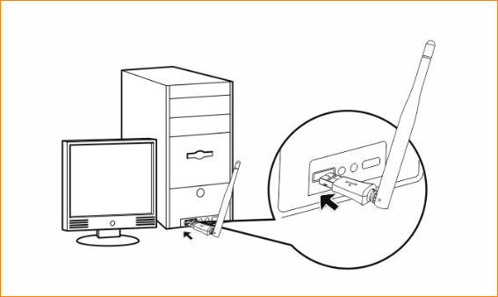
Note: Set the adapter’s antenna vertical.
1) After you insert the adapter, the PC will pop a dialog box automatically, Click Run AutoInst.exe in the dialog box
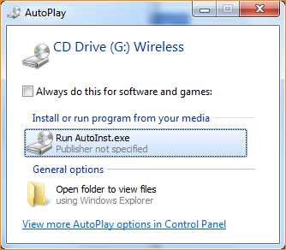
2) Waiting for the setup program run complete, restart the PC and enjoy the Wi-Fi.
